**CHAMPIONS TROPHY 2025 ANALYSIS:**

Hello Gigs,

Happy to share with you my latest project on champions trophy 2025. In this I build a dashboard from scratch.

From collecting, gathering and importing data from various sites and from official ICC website to visualizing data it’s a great experience for me. Its also include cleaning and structuring data, data calculations, modelling data and dashboard design.

**Calculations:**

1. Team Win Rate:

=Total Wins / total_Matches *100

=D2/C2*100

1. Bowler Economy Rate:

Economy Rate = Total Runs Conducted / Total Overs Bowled

E.g E.R= 58 Runs / 9.5 Overs = 6.11

1. Batsmen Strike Rate:

Batting Strike Rate = (Total Runs Scored / Total Balls Faced) * 100.

1. Batsman Batting Average:

Batting Average = (Total Runs Scored) / (Number of Dismissals)

No of dismissal means batman is out, if batsman is not out then its not count in dismissal.

**Data Model:**

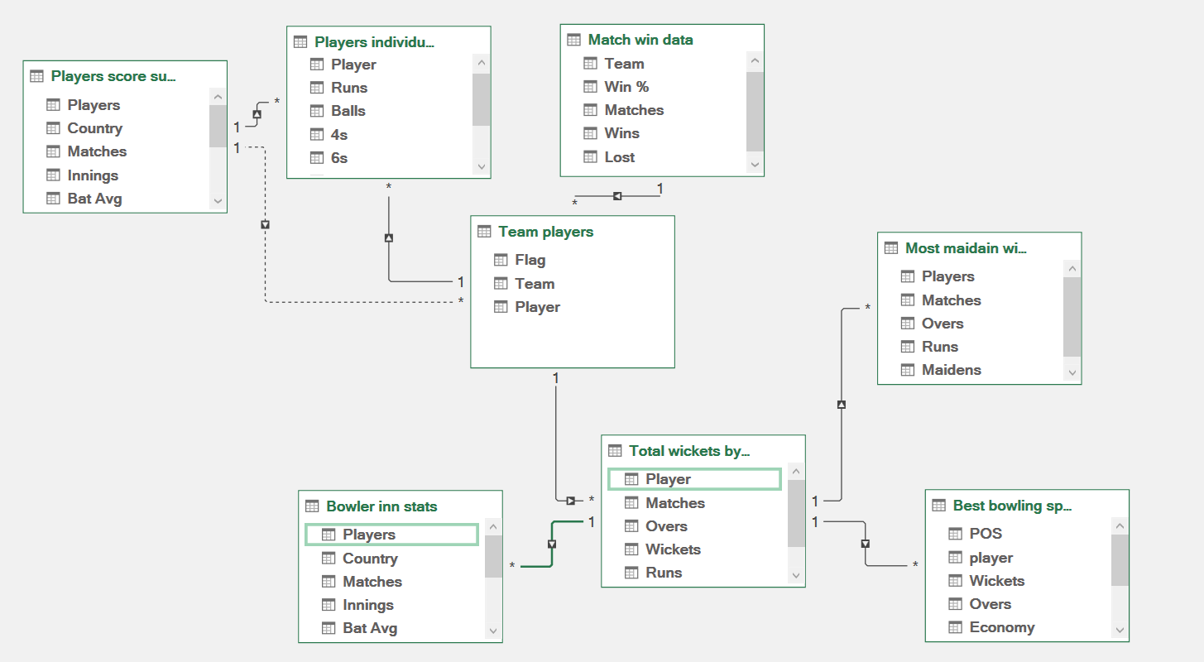

**Dashboard:**

